Lab 3 php Craciun Dan

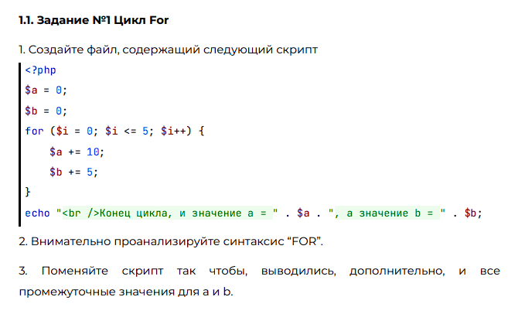

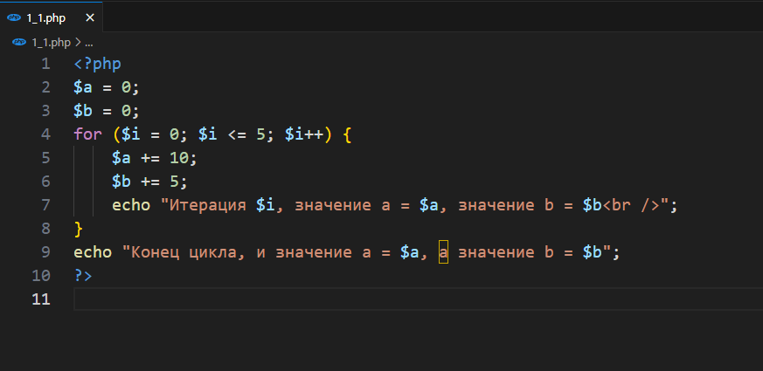



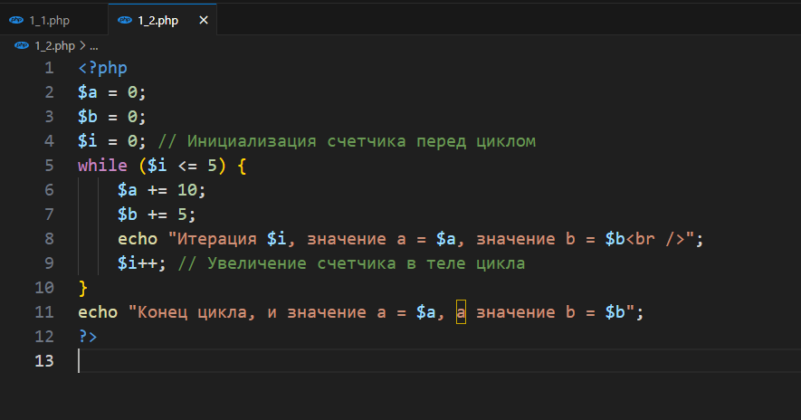

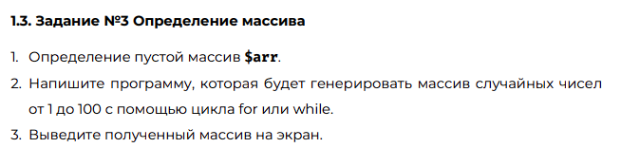

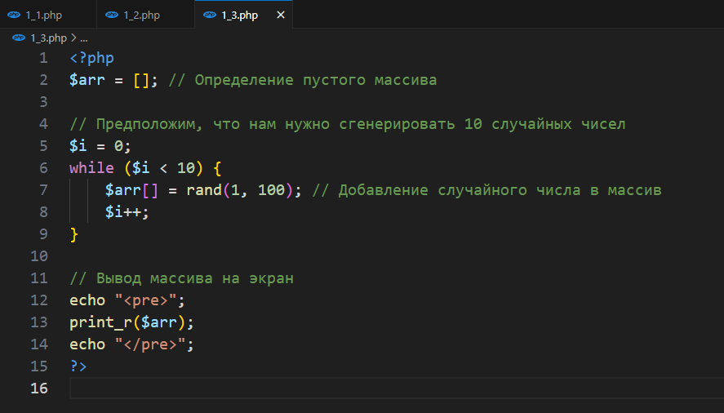

**1.4. Задание №4 Использование массивов и функций**

**<?php**

**// Определение ассоциативного массива транзакций**

**$transactions = [**

**[**

**"transaction_id" => 1,**

**"transaction_date" => "2019-01-01",**

**"transaction_amount" => 100.00,**

**"transaction_description" => "Payment for groceries",**

**"merchant_name" => "SuperMart",**

**],**

**[**

**"transaction_id" => 2,**

**"transaction_date" => "2020-02-15",**

**"transaction_amount" => 75.50,**

**"transaction_description" => "Dinner with friends",**

**"merchant_name" => "Local Restaurant",**

**],**

**// Добавлены новые транзакции**

**[**

**"transaction_id" => 3,**

**"transaction_date" => "2021-03-22",**

**"transaction_amount" => 50.00,**

**"transaction_description" => "Books purchase",**

**"merchant_name" => "Bookstore",**

**],**

**[**

**"transaction_id" => 4,**

**"transaction_date" => "2021-04-01",**

**"transaction_amount" => 150.00,**

**"transaction_description" => "Monthly rent",**

**"merchant_name" => "Apartment",**

**],**

**];**

**// Функции для работы с транзакциями**

**function calculateTotalAmount($transactions) {**

**$total = 0;**

**foreach ($transactions as $transaction) {**

**$total += $transaction["transaction_amount"];**

**}**

**return $total;**

**}**

**function calculateAverage($transactions) {**

**$total = calculateTotalAmount($transactions);**

**return $total / count($transactions);**

**}**

**function mapTransactionDescriptions($transactions) {**

**return array_map(function ($transaction) {**

**return $transaction["transaction_description"];**

**}, $transactions);**

**}**

**// Вывод транзакций**

**?>**

**<table border="1">**

**<tr style="background-color: #a6a6a6; color: #252525">**

**<th colspan="5">Данные о транзакциях</th>**

**</tr>**

**<tr style="background-color: #a6a6a6; color: #252525">**

**<th>ID</th>**

**<th>Дата</th>**

**<th>Сумма транзакции</th>**

**<th>Описание транзакции</th>**

**<th>Название организации</th>**

**</tr>**

**<?php foreach ($transactions as $transaction) : ?>**

**<tr>**

**<td><?php echo $transaction["transaction_id"]; ?></td>**

**<td><?php echo $transaction["transaction_date"]; ?></td>**

**<td><?php echo $transaction["transaction_amount"]; ?></td>**

**<td><?php echo $transaction["transaction_description"]; ?></td>**

**<td><?php echo $transaction["merchant_name"]; ?></td>**

**</tr>**

**<?php endforeach; ?>**

**</table>**

**<?php**

**// Вывод результатов функций**

**echo "Общая сумма транзакций: " . calculateTotalAmount($transactions) . "<br>";**

**echo "Средняя сумма транзакции: " . calculateAverage($transactions) . "<br>";**

**echo "Описания транзакций: " . implode(", ", mapTransactionDescriptions($transactions)) . "<br>";**

**?>**

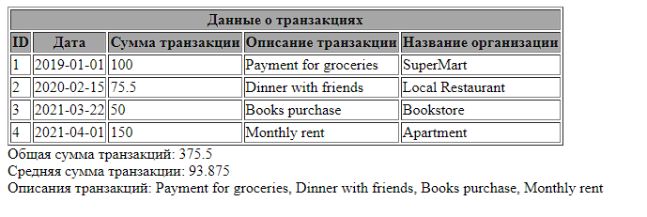

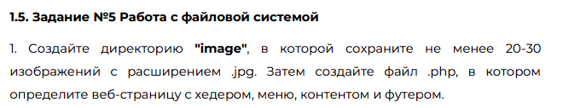

**<!DOCTYPE html>**

**<html lang="en">**

**<head>**

**<meta charset="UTF-8">**

**<title>Gallery of Cats</title>**

**<style>**

**header, footer {**

**background-color: #333;**

**color: white;**

**text-align: center;**

**padding: 1em;**

**}**

**nav {**

**text-align: center;**

**margin: 10px;**

**}**

**nav a {**

**text-decoration: none;**

**color: white;**

**margin: 0 10px;**

**}**

**.content {**

**display: grid;**

**grid-template-columns: repeat(auto-fill, minmax(200px, 1fr));**

**grid-gap: 10px;**

**padding: 10px;**

**}**

**.content img {**

**width: 100%;**

**height: auto;**

**}**

**</style>**

**</head>**

**<body>**

**<header>**

**<h1>About Cats</h1>**

**<nav>**

**<a href="#">About Cats</a> |**

**<a href="#">News</a> |**

**<a href="#">Contacts</a>**

**</nav>**

**<input type="search" placeholder="Search...">**

**</header>**

**<section class="content">**

**<h2>#cats</h2>**

**<p>Explore a world of cats</p>**

**<!-- PHP код для вывода изображений -->**

**<?php**

**$directory = "image"; // Путь к директории с изображениями**

**$images = glob($directory . "/*.jpg"); // Получение списка изображений**

**foreach ($images as $image) {**

**echo "<img src='" . htmlspecialchars($image) . "' alt='Cat'>";**

**}**

**?>**

**</section>**

**<footer>**

**<p>&copy; 2024 Cat Gallery</p>**

**</footer>**

**</body>**

**</html>**

